**Chapter 1 – Introduction**

* 1. **Introduction**
* MyLDRP is an contains *Automated Attendance system with SMS & Email Notification* which calculates Attendances and generate Notifications via different methods, also this system provides functionalities like Report Generation, SMS Notification.
* Using this system User can view Attendance, Timetable, Marks.
* The website is very useful to Students & Faculties of LDRP.
* The interface of this website is straight forward and takes you roughly a minute to get started.
  1. **Scope**
* The web-application is titled Automated Attendance system with SMS & Email Notification.
* This web-application is intended for LDRP-ITR.
* The objective of this website is to save time of Faculty and Make easy access of details to students.
* Provides easy way to Faculty to Generate PDF, Excel or Direct Print Attendance Reports.
  1. **Project summary and Purpose**
* The purpose of this web-application is to provide online information about Academic Details like Attendance, Time-Table, Marks.
* Faculties don’t need to count each class’s each subject Attendance, this system can automatically count and stores it.
* This web-application also provides Function of SMS & Email Notification.
* SMS & Email Notification also works automatically and bases on attendance and Threshold Percentage Students Parents are notified by SMS & Email (Automatically)
  1. **Overview of the project**
* The web-application of Automated Attendance System is called MyLDRP.
* This system will mine data from Google Sheets and stores it inside Database.
* System will also generate Weekly reports automatically.
* Alongside weekly reports system will send Email & SMS notifications to Students Parents by it self.
* Front End web-portal for Faculty provided to generate reports manually in different file format.
  1. **Problem Definition**
* Normally, Attendance are stored in books and it is time consuming to count attendance for each and every class.
* This system will count Attendance for each subject of each class and generate combined of subject’s attendance weekly reports.
* The weekly reports will help Faculty to analyze Students attendance more easily and quickly.
* This system will mine data from Google Sheets and stores it inside Database.
* Faculty can view any student’s attendance by inserting student’s Enrollment number in Quick Search.
* Additionally, Faculty can view or generate pdf for whole class’s Attendance for all subjects combined.
* More over, Time tables can be also view from this portal and PDF can also Downloaded for easy distribution among students.
* Before it was tough to notify parents about Students attendance, now with this system it is makes easy way to notify parents via SMS & Email.
* Student’s Mid-semester Marks or Final Grad can be seen also from faculty-portal of this system.

**Chapter 2 - Technology and Literature Review**

* 1. **About Tools and Technology**

We have used PHP,HTML5,CSS3,Angular JS, JQuery for this project and we also used AJAX technology. This system is Structured in MVC Format.

**AJAX**

AJAX = Asynchronous JavaScript and XML.

AJAX is a technique for creating fast and dynamic web pages. AJAX allows web pages to be updated asynchronously by exchanging small amounts of data with the server behind the scenes. This means that it is possible to update parts of a web page, without reloading the whole page. Classic web pages, (which do not use AJAX) must reload the entire page if the content should change

AJAX is about updating parts of a web page, without reloading the whole page.

**How AJAX work?**

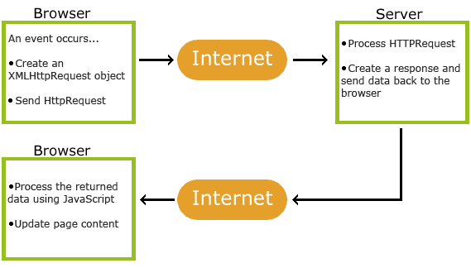

**Fig 2(a): AJAX**

**MVC**

MVC = Model View Controller.

MVC, or Model-View-Controller is a software architecture, or design pattern, that is used in software engineering, whose fundamental principle is based on the idea that the logic of an application should be separated from its presentation. Put simply, one would say that MVC is simply a better way of separating the logic of your application from the display.

**How MVC work?**

**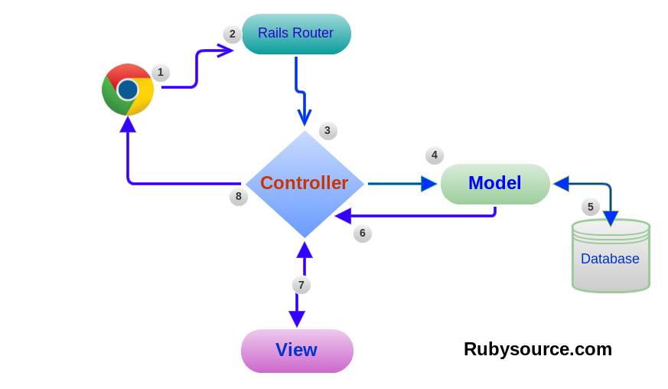**

**Fig 2(b): MVC**

**PHP**

**PHP** is a server-side scripting language designed for web development but also used as a general-purpose programming language. Originally created by Rasmus Lerdorf in 1994, the **PHP** reference implementation is now produced by The **PHP** Group.

The best things in using PHP are that it is extremely simple for a newcomer, but offers many advanced features for a professional programmer. Don't be afraid reading the long list of PHP's features. You can jump in, in a short time, and start writing simple scripts in a few hours.

**Angular JS**

Angular JS is a structural framework for dynamic web apps. It lets you use HTML as your template language and lets you extend HTML's syntax to express your application's components clearly and succinctly. Angular's data binding and dependency injection eliminate much of the code you would otherwise have to write.

Angular is what HTML would have been, had it been designed for applications. HTML is a great declarative language for static documents. It does not contain much in the way of creating applications, and as a result building web applications is an exercise in what do I have to do to trick the browser into doing what I want?

Angular takes another approach. It attempts to minimize the impedance mismatch between document centric HTML and what an application needs by creating new HTML constructs. Angular teaches the browser new syntax through a construct we call directives. Examples include:

* Data binding, as in {{}}.
* DOM control structures for repeating, showing and hiding DOM fragments.
* Support for forms and form validation.
* Attaching new behavior to DOM elements, such as DOM event handling.
* Grouping of HTML into reusable components.

**JQuery**

jQuery is a fast, small, and feature-rich JavaScript library. It makes things like HTML document traversal and manipulation, event handling, animation, and Ajax much simpler with an easy-to-use API that works across a multitude of browsers.

**Java Scripts**

JavaScript is an interpreted programming or script language from Netscape. It is somewhat similar in capability to Microsoft's Visual Basic, Sun's Tcl, the UNIX-derived Perl, and IBM's REXX. In general, script languages are easier and faster to code in than the more structured and compiled languages such as C and C++. Script languages generally take longer to process than compiled languages, but are very useful for shorter programs.

**2.2 Brief History of Work Done**

* **Project Plan**

|  |  |  |  |
| --- | --- | --- | --- |
| **No.** | **Activity** | **Days** | **Approx. Weeks** |
| 1 | Defining Project | 7 7 | 11 1 |
| 2 | Understanding Problem Definition and System Requirements | 15 13 | 2 2 |
| 3 | System Design | 30 30 | 4 |
| 4 | Diagrams | 10 12 | 2 2 |
| 5 | Data Dictionary | 14 15 | 2 2 |
| 6 | Form Design | 14 13 | 2 2 |
| 7 | Project Coding | 60 65 | 8 8 |
| 8 | Testing & Debugging | W 10 | 2 |

**Chapter 3 - System Requirements Study**

* 1. **User Characteristics**
* **Admin:** It can perform various operations.
* Insert Link of Google Sheets for each Subjects
* Create Faculty User
* Send SMS Notification.
* Manage Time-Table
* Maintain System
* **Faculty:** It can perform various operations.
* Login
* Student Attendance Search Using Quick Search.
* Class wise attendance between two specific dates.
* Generate PDF or Excel reports.
* Send Message Directly to Parents using enrolment number.
* **Student:** It can perform various operations. (Future Development)
* View Mid Semester Marks.
* Can view Final Examination Grads.
* Can see time-table
* Search for their attendance for specific dates.
  1. **Hardware and Software Requirements**

This product is developed mainly using open source technologies like PHP, JQuery, Angular JS, MVC, MySQL etc.

**Software Requirements**

* **Server Side:** -
* Database :- MySQL
* Framework :- None (Larval For future purposes)
* **Client Side:** -
* Operating System :- Any (Windows, IOS, Linux)
* Browser :- Any compatible browser

**Hardware Requirements**

* **Server Side:** -
* Processor :- Intel core i5, 3.1GHz
* RAM :- 2 GB or More
* Storage :- 10-15GB (with Rapid Backup)
* **Client Side:** -
* Processor :- Core @ duo processor 1.8 GHz
* RAM :- 512 MB or More
* HDD :- 100-150 MB (to store cash Files of App)
  1. **Assumptions and Dependencies**
* **Assumptions**
* The code should be free with compilation errors/syntax errors.
* The system must have an interface which is simple enough to understand.
* **Dependencies**
* The proposed system would be designed, developed and implemented based on the software requirements specifications document.
* High speed internet is required.
* Google API & Google Sheets Access required.

**Chapter 4 - System Analysis**

* 1. **Study of Current System**
* When the process of working on this website started, a lot of research was done about how to mine data from Google Sheets or how to make automate work with different sheets formats .
* It is very complex to understand the whole process of system.
* Also, some statistical studies and reports were studied before and during the development of this website, to understand the PHP Market trends, how other websites of this type are behaving in the real market.
  1. **Requirements of New System**
     1. **Developer Requirements**

In order to make this System functional, Developer require the following:

* Access to Corn Job manager to setup Corn jobs of System.
* Links of Google Sheets Containing Attendance.
* SMS API to Provide SMS Functionality.
* SMTP Server to generate mails.
  + 1. **System Requirements**
* PHP 5.6+ is used.
* PHPStrom, Con job Manager is to be installed.
* MySQL should be used for database.

**4.2.3 User Requirements**

* An Internet connection
* Any one of Most Updated Web Browser
  1. **Feasibility Study**

Depending on the results of the initial investigation, the survey is expanded to a more detailed feasibility study. Feasibility study is a test of system proposal.

According to its work ability, impact on the organization, ability to meet user needs, and effective use of resources. The objective for this phase is not to solve the problem but to acquire a sense of scope. During the study, the problem definition is crystallized and aspects of the problem to be included in the system are determined.

We started the project by listing the possible queries that the user might want to be satisfied. And on these lines we guided the project further.

The three main points, kept in mind at the time of project, are:

* Possible (To build it with the given technology and resources)
* Affordable (given the time and cost constraints of the organization)
* Acceptable (for use by the eventual users of the system)

The three major areas to be considered while determining the feasibility of a project are:

1. **Technical Feasibility**

The technical issue usually raised during the feasibility stage of the investigation includes the following:

* + Does the necessary technology exist to do what is suggested?
  + Do the proposed equipment’s have the technical capacity to hold the data required to use the new system?
  + Will the proposed system provide adequate response to inquiries, regardless of the number or location of users?
  + Can the system be upgraded if developed?
  + Are there technical guarantees of accuracy, reliability, ease of access and data security?

Earlier no system existed to cater to the needs of Secure Infrastructure Implementation System. The current system developed is technically feasible. It is a web based user interface. Thus it provides an easy access to the users. The databases purpose is to create, establish and maintain a work- flow among various entities in order to facilitate all concerned users in their various capacities or roles. Permission to the users would be granted based on the roles specified. Therefore, it provides the technical guarantee of accuracy, reliability and security. The software and hardware requirements for the development of this project are not many and are already available as free as open source. The work for the project is done with the current equipment and existing software technology. Necessary bandwidth exists for providing a fast feed- back to the users irrespective of the number of users using the system.

1. **Operational Feasibility**

Under this category of service, we conduct a study to analysis and determine whether your need can be fulfilled by using a proposed solution. The result of our operational feasibility Study will clearly outline that the solution proposed for your business is operationally workable and conveniently solves your problems under consideration after the proposal is implemented.

I would precisely describe how the system will interact with the systems and persons around. Our feasibility report would provide results of interest to all stakeholders. We will do as per the needs of the business requirements.

1. **Timeline Feasibility**

It is important to understand that a need must be fulfilled when it has to be. Some otherwise feasible and highly desirable projects can become non-feasible due to very restrictive timeline constraints. This fact makes it imperative that milestones are clearly linked to the timeline and projects are well conceived with safe unforeseen margins. We made sure that we strictly follow what has been stated above.

* 1. **Characteristics of the Proposed System**
* **Easiness in modification of data:**

The proposed system provides managing of huge data effectively and efficiently for efficient results, storing the details of the Students, Faculties etc. in such a way that the database can be modified.

* **User friendly:**

The proposed system is user friendly because the retrieval and storing of data is fast and data is maintained efficiently. Moreover, the graphical user interface is provided in the proposed system, which provides user to deal with the system very easily.

* **Reports are easily generated:**

Reports can be easily generated in a proposed system. So any type of reports can be generated in a proposed system, which helps the managers in a decisions- making activity.

* **Computer operator control:**

Computer operator control will be there no errors. Moreover, storing and retrieving of information is easy. So work can be done speedily and in time.

* 1. **Features of New System**

## Faculty Login Page

* This page displays the login with validation. If the user name is invalid then it will display the validation with the use of Ajax control tool kit.

## Dashboard

* After successful login Faculty can log in to their dashboard section.
* Faculty can use quick search to find any specific user’s Attendance.
* PDF or Excel Reports can be Generated.

## View Class Attendance between specific dates

## Faculty can view Attendance of Class.

* + PDF or Excel Reports can be Generated.

## View Time Table

* Faculty can view Time-table.

## View Marks Page

* Faculty can view Marks of Students.

## Send Notification Page

## SMS & Email Notification can be send.

* 1. **Class Diagram**

class

**Fig 4(a): Class Diagram**

* 1. **Activity Diagram**

**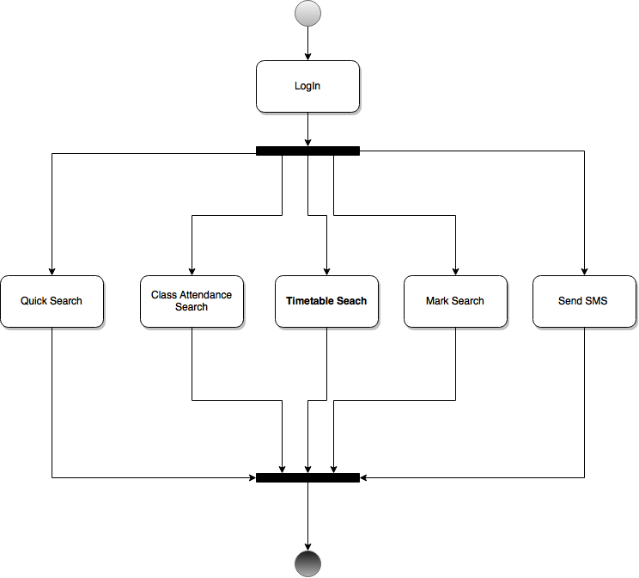**

**Fig 4(b): User Activity Diagram**

* 1. **Use Case Diagram**

**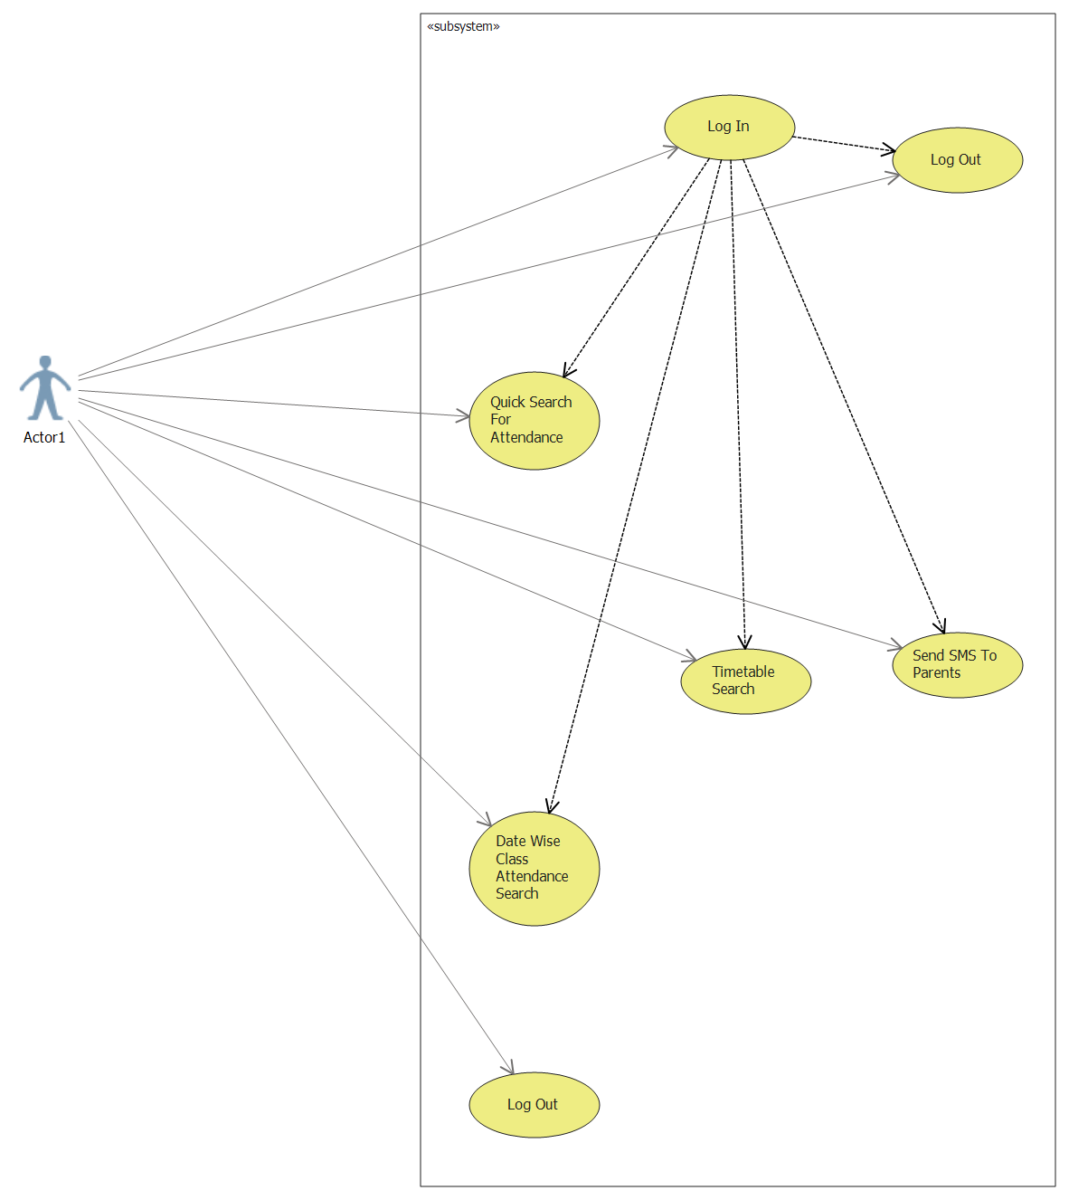**

**Fig 4(c): Use Case Diagram**

* 1. **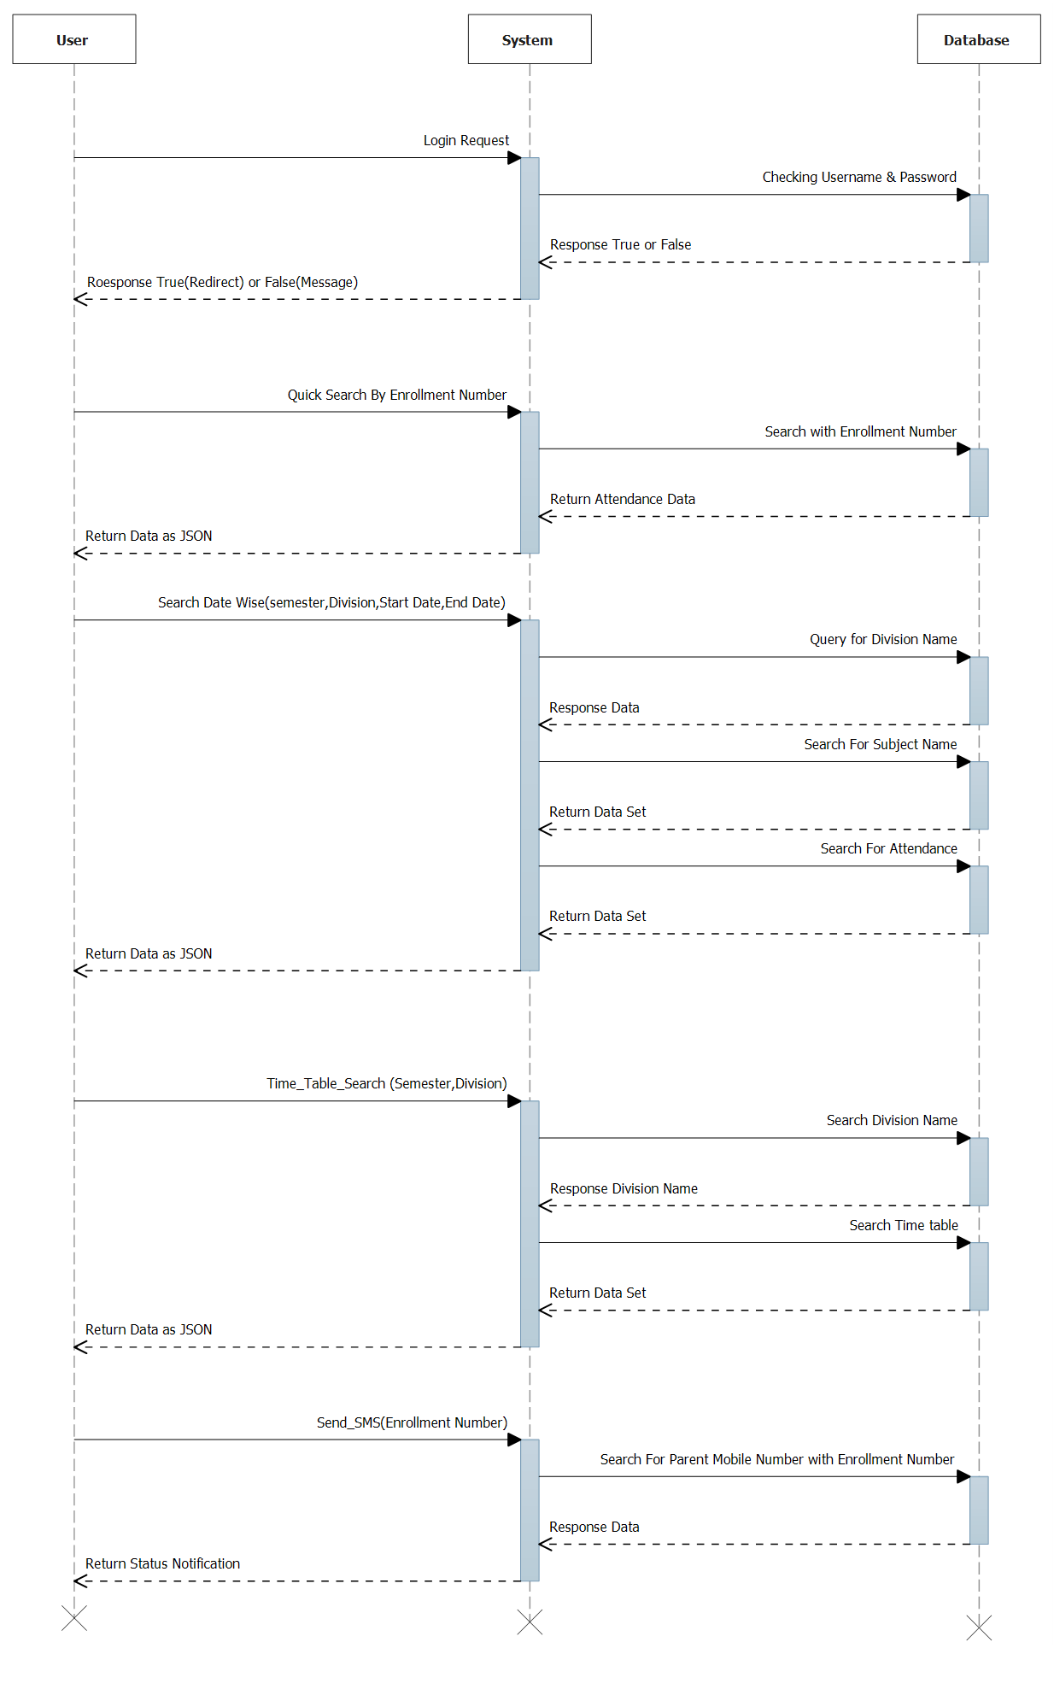Sequence Diagram**

**Fig 4(d): Sequence Diagram**

**4.11Flow Diagram**

**Activity_Process_data**

**Fig 4(e): Flow Diagram**

**Chapter 5 - System Design**

* 1. **Database Design**
* **Table Name:** Att\_testing\_struct

**Description:** This table is used to store Attendance.

**Primary Key:** Sr no.

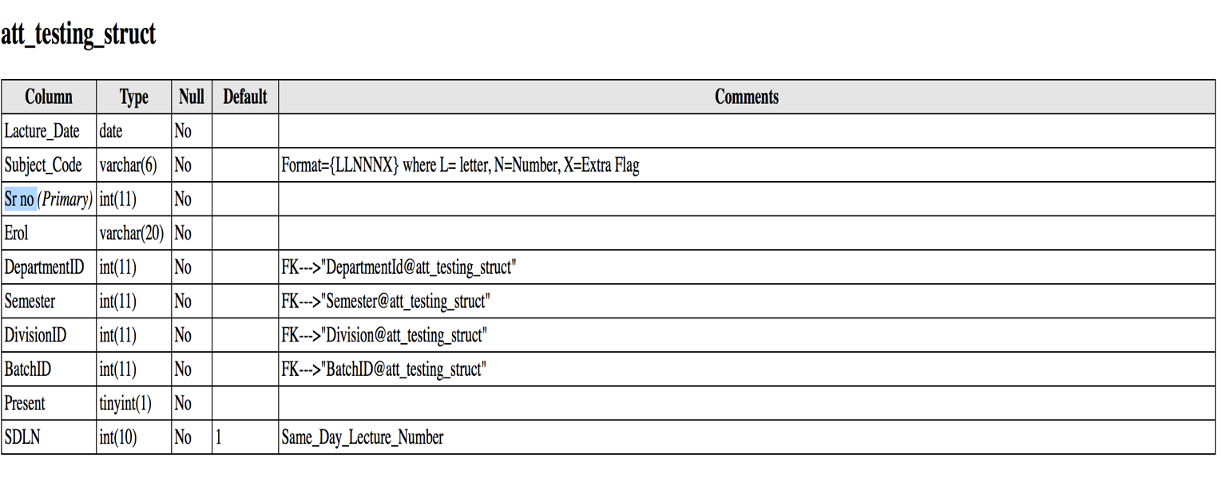

* **Table Name:** Batch\_Year

**Description:** This table is used to store Batch Years.

**Primary Key:** Batch\_YearID

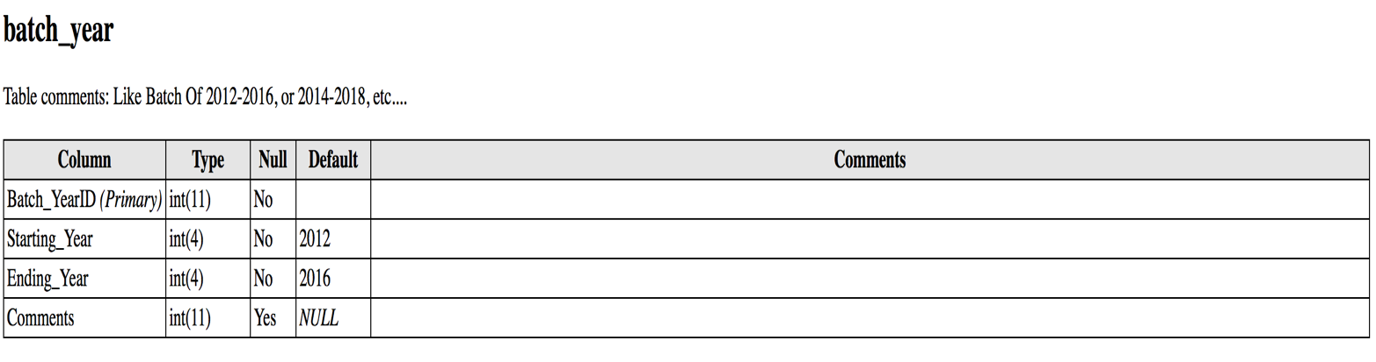

* **Table Name:** Department\_Data

**Description:** This table is used to store Department\_data.

**Primary Key:** Dapartment\_ID

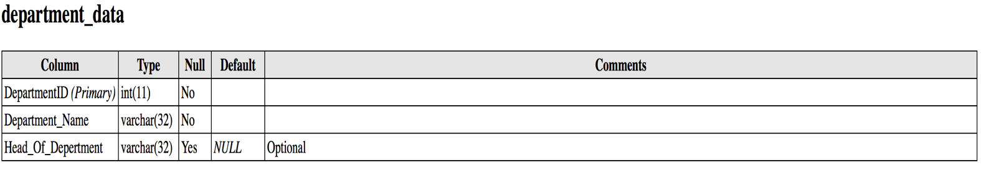

* **Table Name:** Division\_Data

**Description:** This table is used to store Division Data.

**Primary Key:** DivisionID

**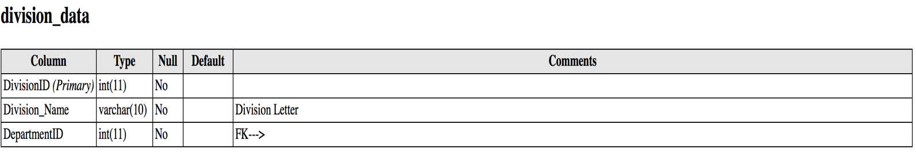**

* **Table Name:** Faculty Data

**Description:** This table is used to store Faculty Data.

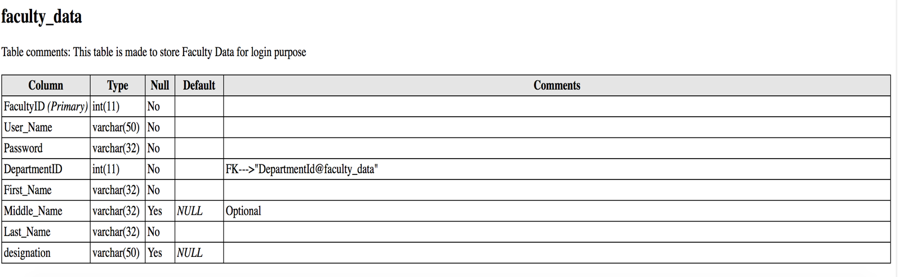 **Primary Key:** FacultyID

* **Table Name:** Index of Google Sheet

**Description:** This table is used to store Index of Google Sheet.

**Primary Key:** sr no.

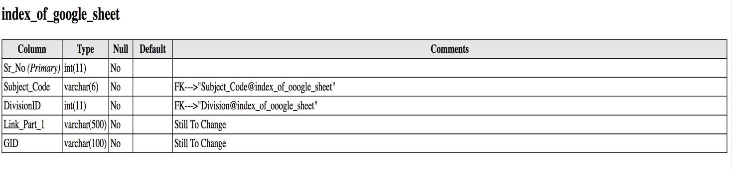

* **Table Name:** Semester Start End Date

**Description:** This table is used to store Semester Start End Date.

**Primary Key:** Start End Date

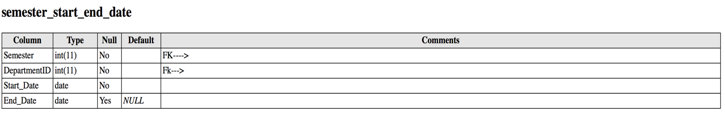

* **Table Name:** Student Data

**Description:** This table is used to store Student Data.

**Primary Key:** StudentId

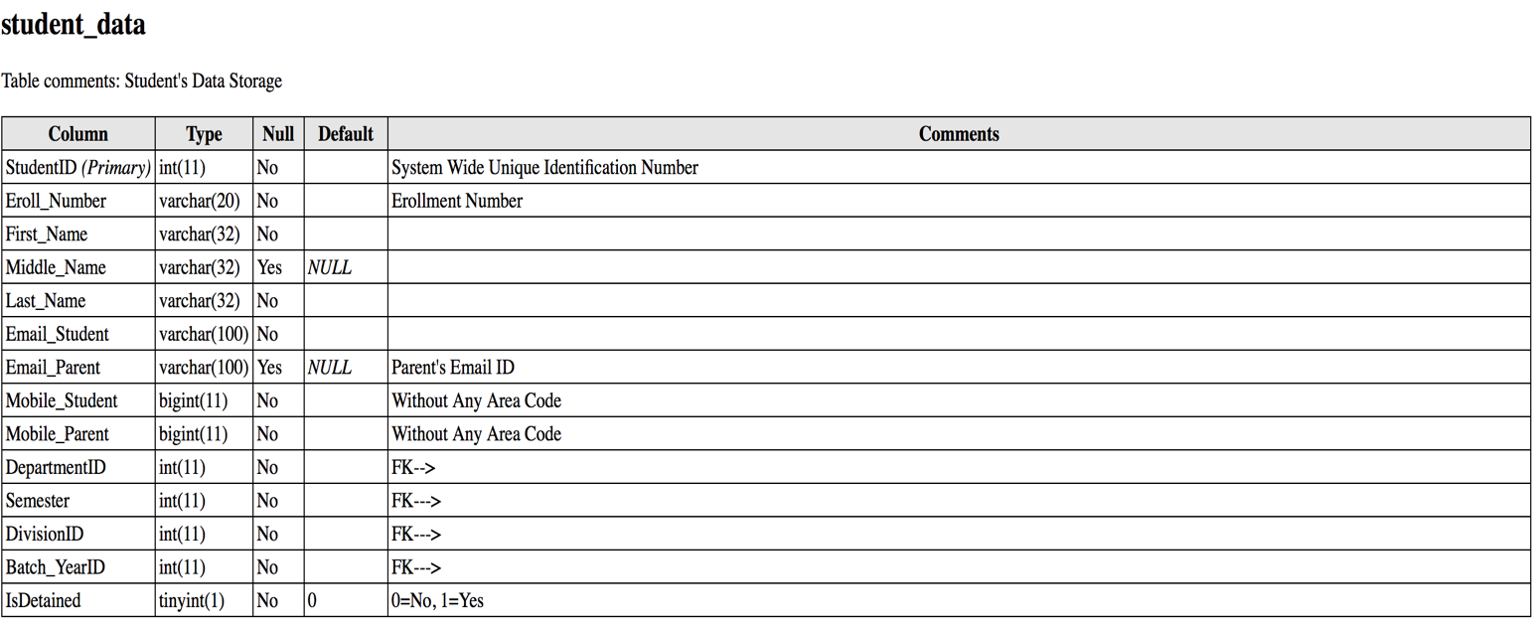

* **Table Name:** Subject\_data

**Description:** This table is used to Subject\_data.

**Primary Key:** Sr No.

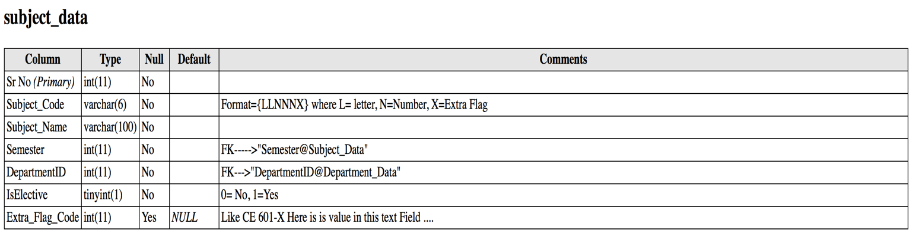

* **Table Name:** Subject\_Teching\_Faculty\_record

**Description:** This table is used to store Subject Teching Faculty record.

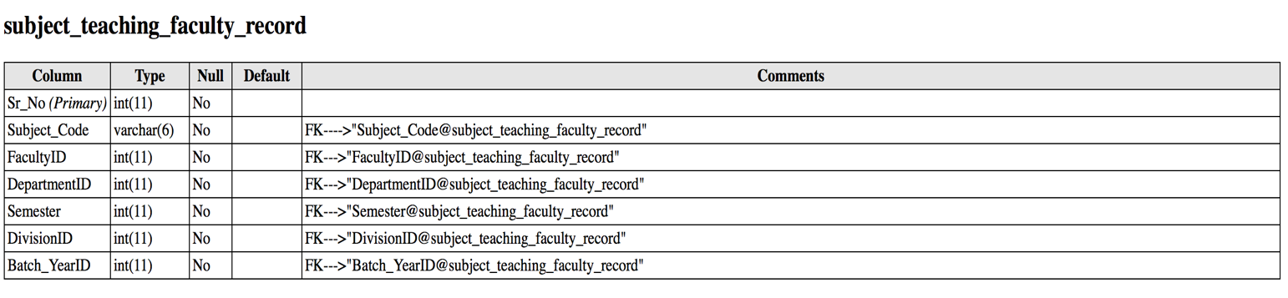 **Primary Key:** sr\_no

* **Table Name:** Status\_Type\_Master

**Description:** This table is used to store status detail.

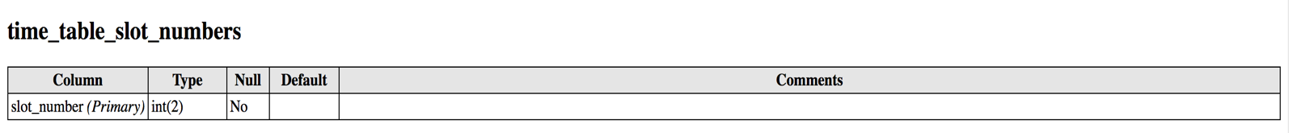 **Primary Key:** Status\_Type\_Id

* 1. **Input/Output and Interface Design**

**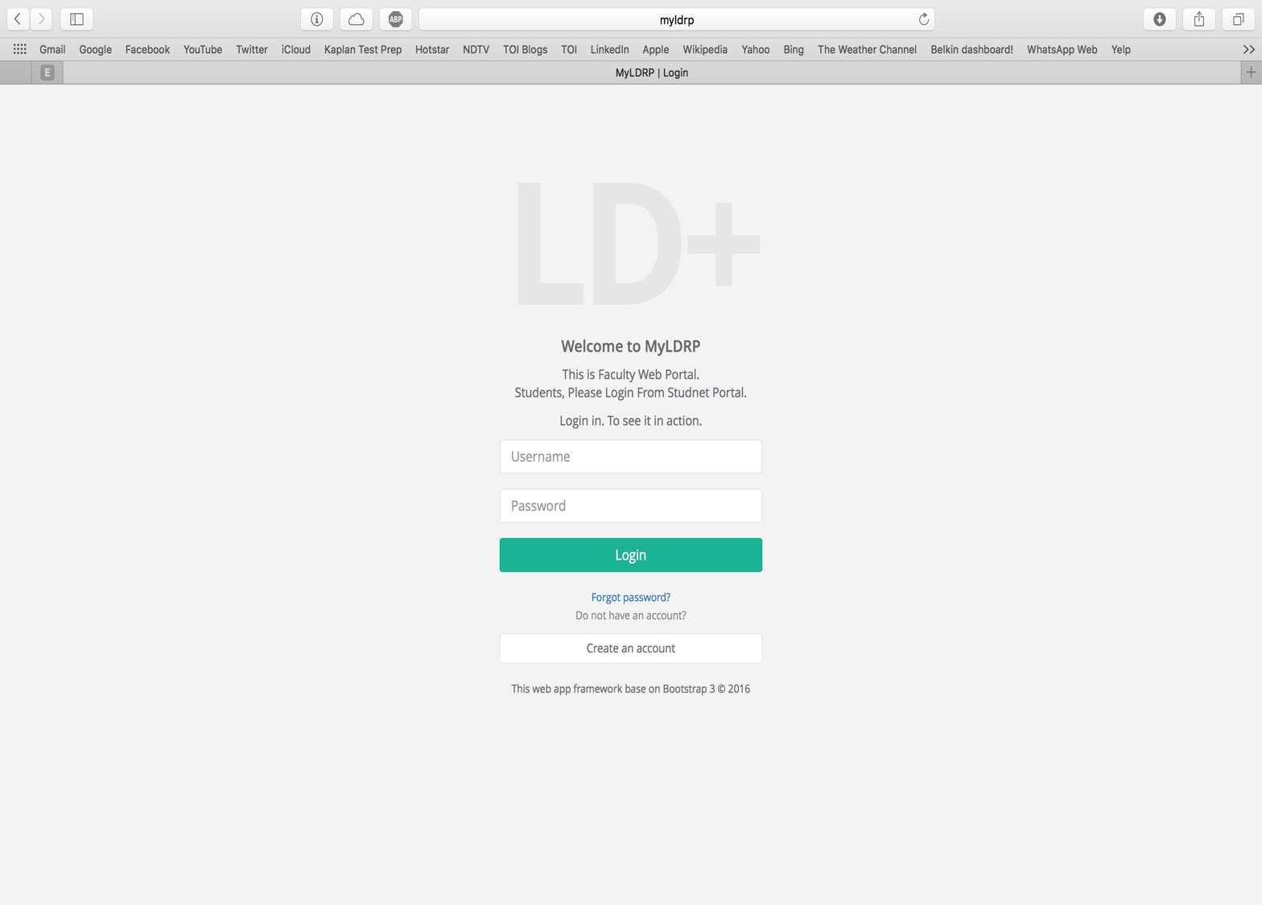**

**Fig 5(a): Login Page**

**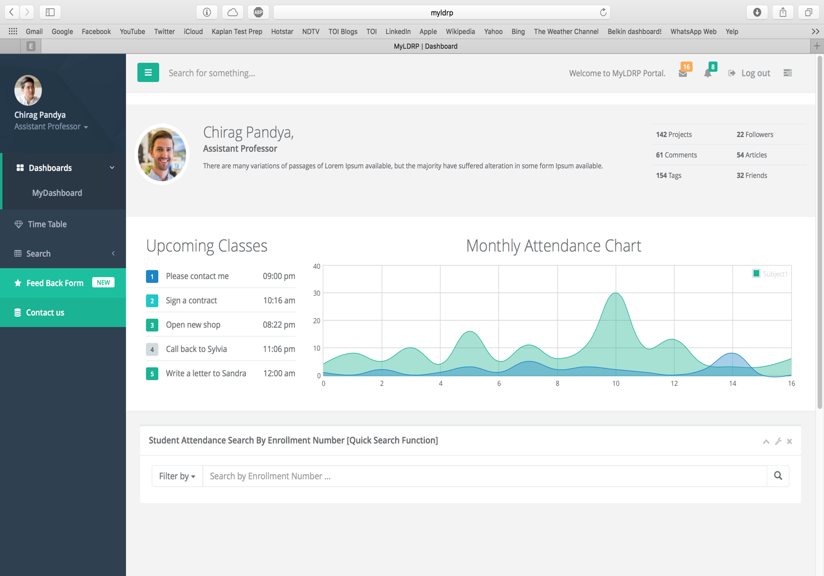**

**Fig 5(b): Home Page**

**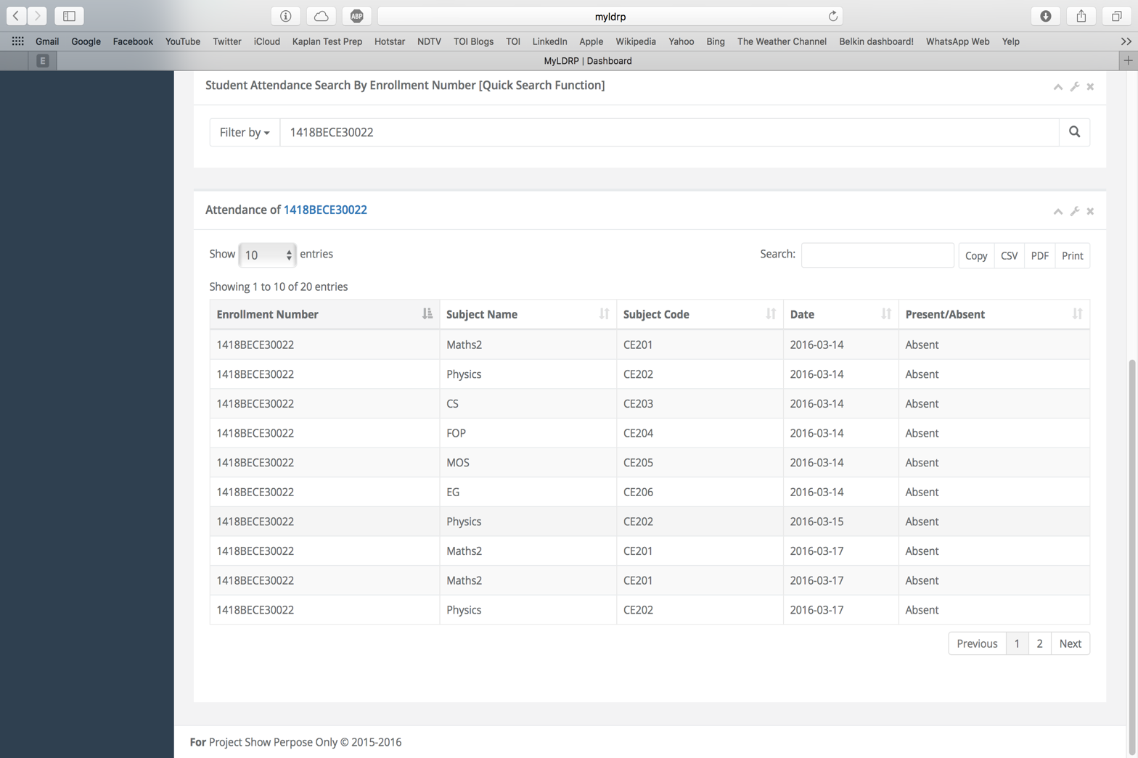**

**Fig 5(c): Result Of Quick Search**

**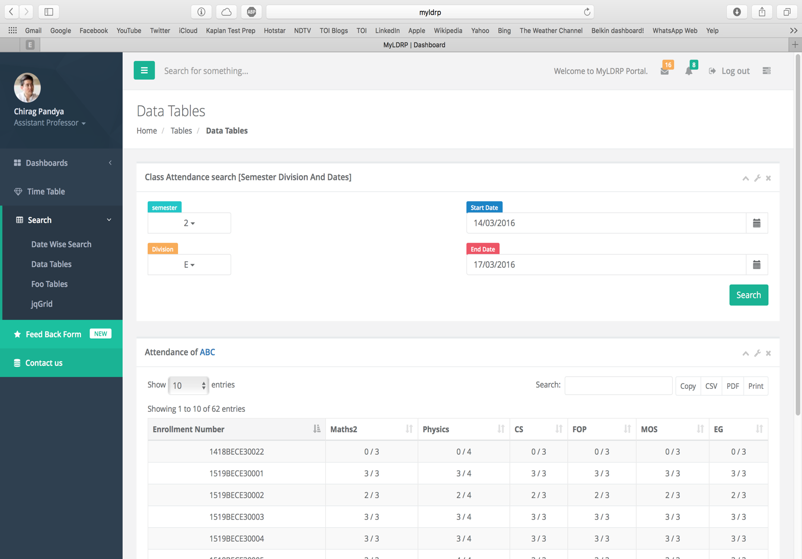**

**Fig 5(d): Date Wise Search**

**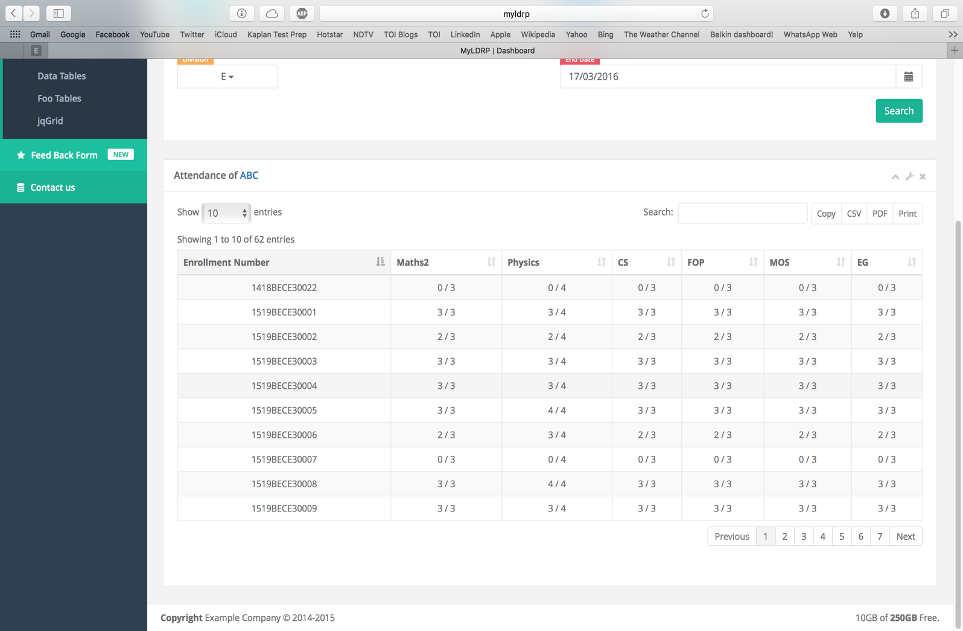**

**Fig 5(e): Date Wise Search Results**

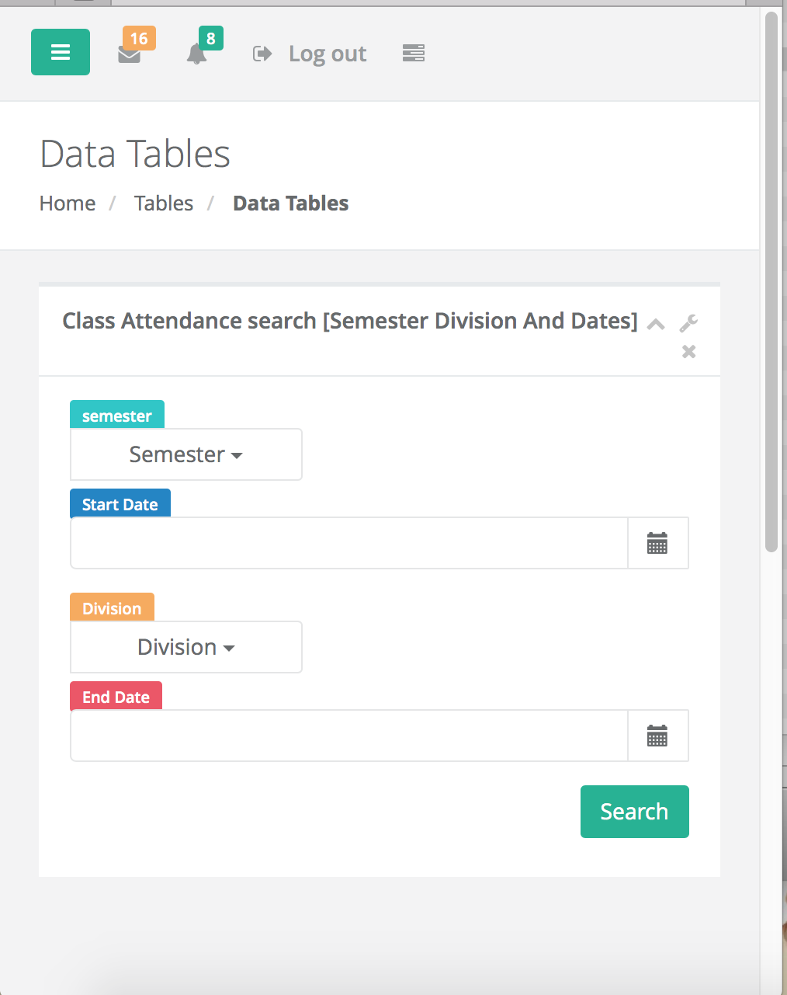

**Fig 5(f): Responsive Web Application**

**Chapter 6 – System Testing**

**6.1 Testing Method**

### Black-Box Testing

The technique of testing without having any knowledge of the interior workings of the application is called black-box testing. The tester is oblivious to the system architecture and does not have access to the source code. Typically, while performing a black-box test, a tester will interact with the system's user interface by providing inputs and examining outputs without knowing how and where the inputs are worked upon.

### White-Box Testing

White-box testing is the detailed investigation of internal logic and structure of the code. White-box testing is also called **glass testing** or **open-box testing**. In order to perform**white-box** testing on an application, a tester needs to know the internal workings of the code.The tester needs to have a look inside the source code and find out which unit/chunk of the code is behaving inappropriately.

### Grey-Box Testing

Grey-box testing is a technique to test the application with having a limited knowledge of the internal workings of an application. In software testing, the phrase the more you know, the better carries a lot of weight while testing an application.Mastering the domain of a system always gives the tester an edge over someone with limited domain knowledge. Unlike black-box testing, where the tester only tests the application's user interface; in grey-box testing, the tester has access to design documents and the database. Having this knowledge, a tester can prepare better test data and test scenarios while making a test plan.

**Chapter 7­-Conclusion**

* At the end we would like to conclude that we spent a lot of time on implementing the various features in the website.
* We would like to mention that, it was a not an easy job to co-ordinate with a team which is located at a different geographical location, far away from my current location.
* We would like to mention that this website has a couple of nice features like Report Generation.
* At the end we conclude by saying that apart from its limitations, the features existing in the website as of now are interesting and will satisfy the basic demands of the users.

**Chapter 8 –Bibliography**

* www.youtube.com/user/PHP
* www.w3schools.com/PHP.net/mvc\_publish.php
* www.php.net/get-started/websites
* PHP MVC Step-by-Step